For now, we created our first database, with our first thoughts.

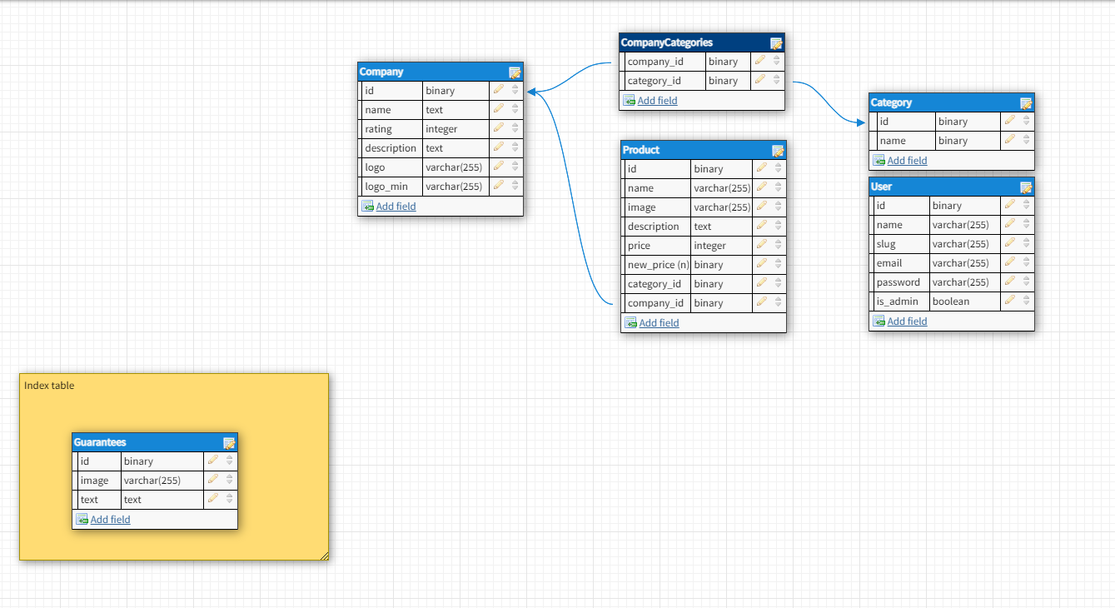

It will be changed later, I guess. For our Django project I`m added new path “” for general urlpatterns. 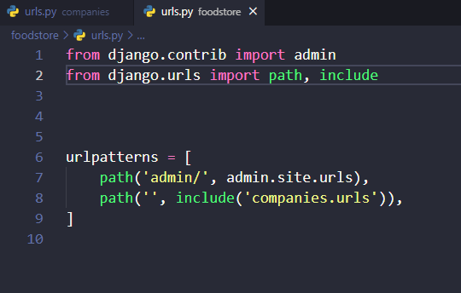

And, urlpattern for my actual app. 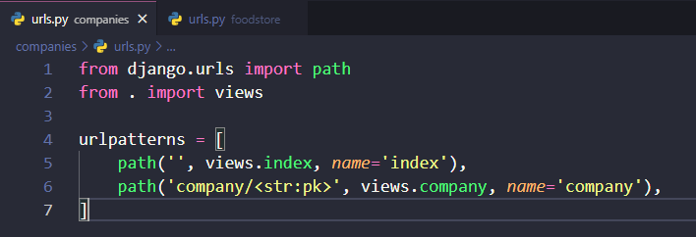

After urls.py we gotta go to the views.py file. For our two pattens there are two functions, responsible for them.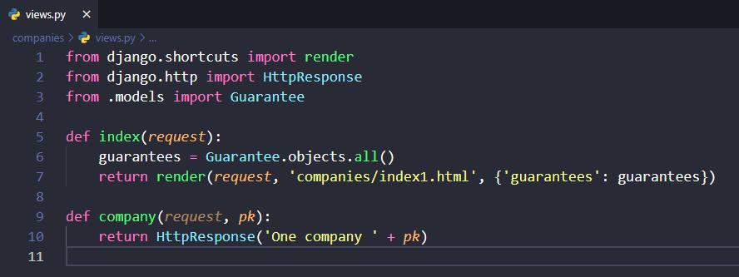

Function index renders index1.html file.

In that file I succesfully tried to get collection from database.

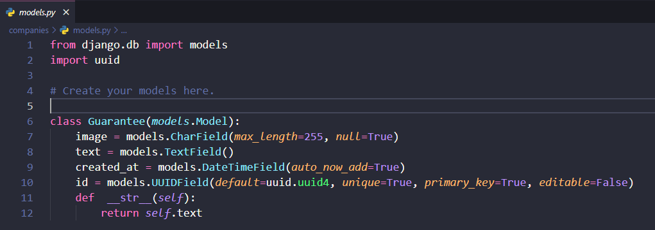

I created filler model that we actually will be usung in our project.

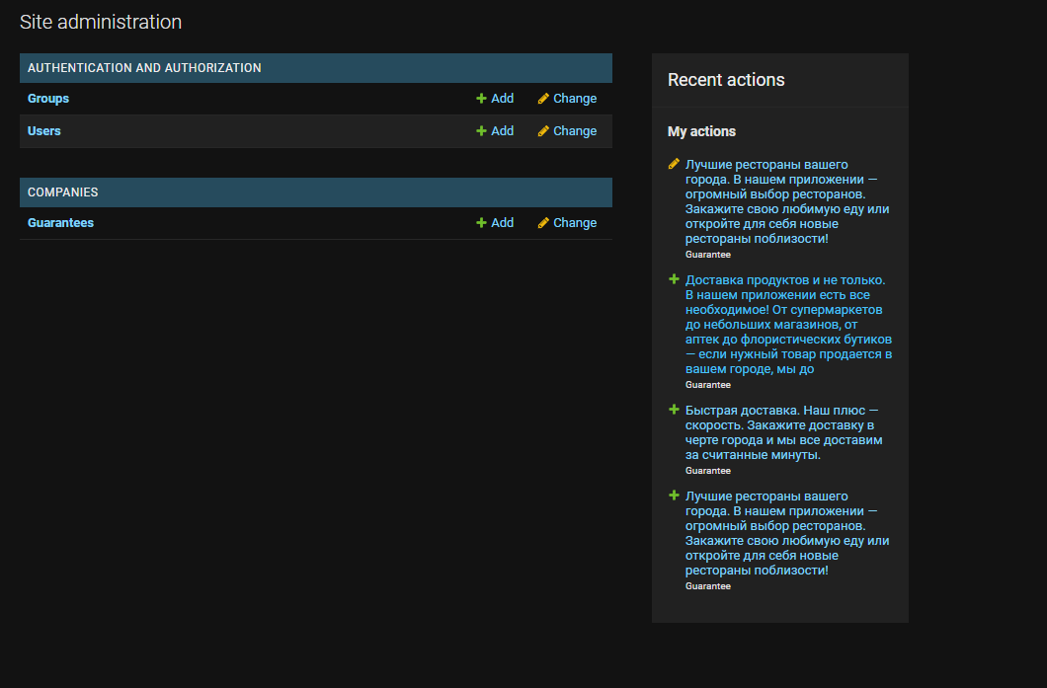

I migrate this model and now we can change it in our admin panel.

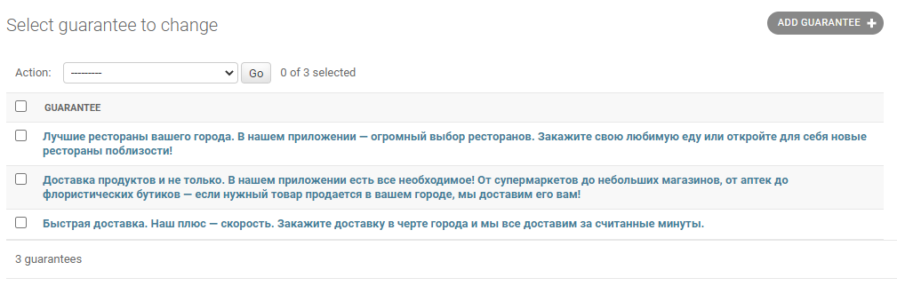

I added three guarantees models.

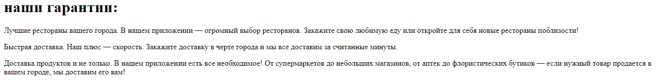

And now we can see org guarantees text